February 2016
Elaine Willette-Larsen
780 753 7880; elaine.willette@teachers.ab.ca; amberzeroone@gmail.com

District Representative Meeting Dates
February 24: Aspen View LC
March 3: Lakeland Catholic LC
March 7: Northern Lights LC
March 8: Greater St. Paul LC
March 9: ECACS EPC Mtg.
March 10: PIA Task Force on Human Services and Reduction of Poverty
March 10: Battle River Constitutional Review
March 10: Battle River Exec
March 10-11: CEATCA Convention
March 11-12: Political Engagement Seminar
March 15: Curriculum Mtg
March 15: Battle River LC
March 16: Park Plains East Resolutions
March 19: Battle River Resolutions
March 23: Aspen View, Greater St. Paul, Lakeland Catholic, & Northern Lights Resolutions
April 4: Battle River Exec
April 6: Role of Superintendent Mtg.
April 6: Aspen View LC
April 7-8: Provincial Executive Council
April 8: NETCA Exec

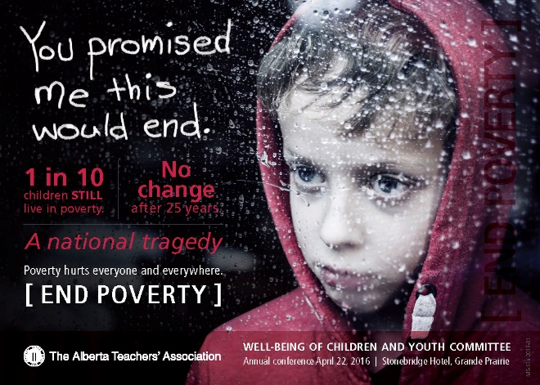

Professional Development

Webinars: are offered in conjunction with the Alberta Regional Learning Consortium. See schedule below and find archived events here.
Supporting Positive Behaviours in Alberta  Schools  Part I March 14, 2016  Part II March 21, 2016 | Unseen Hurts: Understanding Mental Health  Issues in Our Classrooms  Part I April 14, 2016  Part II April 21, 2016 | Here Comes Everyone: Teaching in the Culturally Diverse Classroom  2016 04 26  Addressing Learning Disabilities in the Inclusive Classroom May 2016

Diversity, Equity and Human Rights Conference: April 8-9, 2016, Barnett House, Edmonton. Key speakers: Raheel Rahza, current events from a Muslim perspective & Speak Truth To Power, a human rights awareness program featuring Pauline Theoret and Wilton Littlechild. Two members per local are sponsored to attend. Poverty simulation on Friday afternoon.
Teacher Welfare & Government
The “List of All Matters” (LAM) has been separated into a Central Table list and an “Everything” List so that locals have as broad a base to bargain from as possible.

Provincial Executive Council approved a list to take forward to the central table where representatives from our Central Table Bargaining Committee (CTBC) and Teacher Employer Bargaining Association (TEBA) will work out what matters will be bargained for all AB teachers.

Teacher Employer Bargaining Association (TEBA) Board of Directors
The six representatives from school boards are as follows:
John Acheson, Edmonton Catholic Separate School District; Amber Stewart, Calgary School District;
Linda Wellman, Calgary Roman Catholic Separate School District; Colleen Munro, Rocky View School Division; Peter Grad, Medicine Hat Catholic School District; Tammy Henkel, High Prairie School Division

The Government of Alberta has named the following individuals to serve as the eight government representatives:
Lorna Rosen, Deputy Minister, Alberta Education
Philip Bryden, Deputy Minister, Alberta Justice and Solicitor General (former Dean of Law at the University of Alberta)
Lana Lougheed, Deputy Minister, Corporate Human Resources and Public Services Commissioner
Jessica Bowering, Assistant Deputy Minister, Community Policy and Regulations Coordination, Policy Coordination Office, Executive Branch, Government of Alberta
Chief Advisor on Negotiations, Government of Alberta (position currently vacant)
Gene Williams, Assistant Deputy Minister, System Excellence, Alberta Education
Mark Prefontaine, Senior Assistant Deputy Minister, Office of the Deputy Minister, Alberta Treasury Board and Finance
Doug Aitkenhead, Executive Director, Research, System Assurance, Engagement and Teacher Relations Sector, Alberta Education

Teacher Welfare and Government staff have coordinated a communication plan for collective bargaining. The estimation regarding central bargaining is that, while it has started with the creation of the list of all matters and the central table bargaining committee, this portion of bargaining will last into May – June.

Government
**Malatest update: The final report has NOT YET been received by Minister Eggen. He has yet to be briefed on the report from DM Williams.
President Ramsankar and Minister Eggen met and discussed a number of vital public education and professional teacher issues.
The Chief Electoral Officer has withdrawn the investigation on breach of third party advertisement legislation. We believe that the application of the legislation to ATA does not apply and violates freedom of expression under Canadian Charter of Rights and Freedoms (CCRF). We do not know the identity of the complainant even though we have asked.
ARA Resolutions: there are three sets of resolutions
- Current directives (policy) that is expiring
- Resolutions developed by locals
- Resolutions developed by Provincial Executive Council (PEC)
Local ARA delegates need to meet and decide on their prevote for these resolutions. The resolutions will be issued on March 15 with prevote required back to Barnett House by April 15. I have organized three meetings for ARA delegates: March 16 (PPE), March 19 (BR), and March 23 (AV, GSP, LC, NL).
Budget workbook: the resolutions that require funding approval from ARA are packaged separately. Each local needs to submit their budget workbook by March 11 to Barnett House. I will send some notes to provide greater understanding of the resolutions requiring dollars.
Growing Up Digital invitational colloquium: May 27th with a public lecture to precede it on the evening of May 26^{th ($10 ticket)}. This will examine the research the ATA is conducting with Harvard Medical School and School of Public Health and the University of Alberta.
The new “Creating a Compassionate Classroom” booklet that is so popular may be ordered through distribution at Barnett House. Just call.
Political Engagement Seminar: March 11 (eve) and 12 @Barnett House.

Teacher Welfare
Pensions: Alberta Teacher Retirement Fund serves: 39.997 active members, 26,308 retired members and 12,252 inactive members. Contribution rates – will decrease starting 2016 09 01!!
Teacher Welfare Field Services: April 23 @Barnett House.

Member Services
Refrain from getting involved in custody battles. Teachers must remain neutral in these situations.
Exercise caution and prudence with social media and students. Period.
FYI: the first 130 substitute teachers that register for the annual conference receive travel allowance from the association. The allowance is $100 towards accommodation for Friday evening and 53 centre a kilometre (for travel greater than 200 km return). The next Substitute Teachers’ Conference will be 2016 10 28-29.

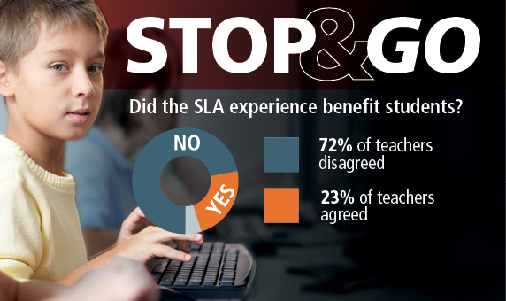

There has been an infographic on SLAs which summarizes the survey of teacher participants. Look for it on the website, and in the ATA News.

Hey! It is Substitute Teachers’ Appreciation Week March 14 – 18. What actions are we taking to demonstrate the importance of our sub teachers??
As always, if you have questions or issues you wish to discuss, please contact me.
Elaine Willette-Larsen
Wellbeing of Children and Youth Conference: “Child Poverty: The Alberta Disadvantage 2.0” April 22, in Grande Prairie. Contact Sandy Gillis at Barnett House for information. Registration is free!

