Central East District Representative’s Report
September 2015
Elaine Willette-Larsen
780 753 7880; elaine.willette@teachers.ab.ca; amberzeroone@gmail.com

DR Meeting Dates  Sept. 24 – 25: Provincial Executive Council  Sept. 28: ECACS EPC Mtg.  Sept. 30: Park Plains East LC Mtg.  Oct. 1: Lakeland Catholic LC Mtg.  Oct. 5: Battle River Exec. Mtg.  Oct. 8: Battle River EPC Mtg.  Oct. 14: Committee on Role of Superintendents  Oct. 15: Selection Committee Mtg.  Oct. 16-17: Religious & Moral Education Conference  Oct. 19: Park Plains Exec. Mtg  Oct. 20: Greater St. Paul LC Mtg.  Oct. 21: Northern Lights LC Mtg.  Oct. 23: WellBeing of Children and Youth Mtg.  Oct. 23: NETCA Exec. Mtg.  Oct. 27: Interview Mtg.  Oct. 28: Aspen View Induction  Oct. 29 – 30: Provincial Executive Council Mtg.  Oct. 30 – 31: Local Presidents’ Mtg/C2 Mtg.  Guidelines for attendance of meetings for District Representatives as approved by ARA  “28.6 The following shall be observed as the appropriate order of priority among Council member assignments:  .1 Council meetings  .2 Provincial committee meetings  .3 Assigned representation functions  .4 Organized meetings with members of the Association at any level involving government political leaders or Alberta Education officials at the Assistant Deputy Minister level or higher  .5 Local association meetings  .6 Specialist council liaison assignments  .7 Teacher convention association meetings  .8 Area conferences  .9 Consultants meetings  (1981 12, 2006 04)” | 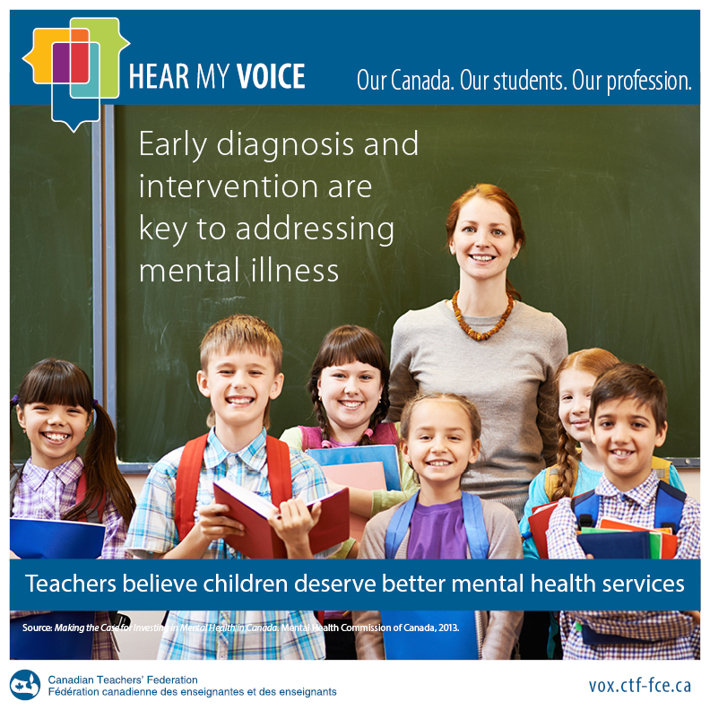  of The ATA News (available in the  newspaper or through this link)  VOTE! October 19 2015 | Upcoming Events  World Teacher Day: October 5  Sub. Teacher Conf: October 16-17  RMEC Conference: October 16-17  PDAC: November 6-7  TWAC: November 20-21  Leadership Essentials for Administrators Conference November 16–17, 2015 - Registration deadline October 31  ATA Educational Trust $500  Specialist Council Conference Grant - Deadline September 30, 2015  Gay/Queer-Straight Student Alliance Handbook  Drawing upon current legislation, law, educational policy and research, this guide describes how best to create and sustain gay–straight alliances (GSAs) or queer–straight alliances (QSAs) in Alberta schools

Professional Development:
Leadership Essentials for Administrators (for new-ish admin). In Calgary at the Sheraton Cavalier on November 16-17. Registration FREE! Speakers look great.
Highlights from the PD survey: the Association calls upon stakeholders to heed seven key recommendations:
1. Ensure sufficient time is given to teachers when students are not in attendance, to
a) Collaborate with their colleagues in a professional learning community setting to benefit student learning and mitigate teacher workload, and
b) Address the goals of their personal professional growth plan;
2. Engage in deliberate teacher workload reduction strategies with an aim to creating time, space and resources that will encourage teachers to engage purposefully and effectively in skill renewal;
3. Enable local efforts to develop policy or secure provisions for teachers that support individually directed professional learning;
4. Reduce the number, variety and intensity of jurisdictional professional development initiatives to allow for sustained and focused teacher learning;
5. Promote a culture that values and invests in the development of contextually relevant and local teacher expertise;
6. Respect the autonomous development of professional growth plans by eliminating the use of mandated templates or externally derived, pre-determined teacher learning goals; and
7. Dismantle structures that bias the distribution of resources to support district and school goals over individually identified professional growth needs.
(http://www.teachers.ab.ca/News%20Room/Announcements/Pages/New-Association-Publications-Available.aspx )

Specialist Council grants were revised (but does not change the budgeted monies). A base grant of $20 000 will be provided to each specialist council with a $25 per member grant. Your membership in a specialist council, especially the smaller ones, helps support them!
Online Professional Growth Plan Tool
  - The ATA, with financial support from Alberta Education, is working on a pilot project to enhance online services for teachers and school leaders’ professional growth planning.
  - If you would like to use the Online Professional Growth Planning Service please click to sign up.

Government:
- Student Learning Assessment – Teacher must have the following:
  - Adequate time for teachers to prepare for, administer and mark the assessments,
  - Appropriate access to working technology and IT support, and
  - Related professional development.
  - Failure to provide adequate supports will create an extraordinary demand on teacher time that may be viewed as a violation of clause C2 of the 2013 Provincial Framework Agreement.
  - The Association continues to make representations to government to address the considerable concerns with the administration of the SLA program, including a call for a moratorium made by the 2015 Annual Representative Assembly.
SLA Survey: an online survey for grade three teachers to present their perspectives on the benefits and challenges associated with SLAs is available. Here is the link
http://www.teachers.ab.ca/News%20Room/WebExtras/Pages/Grade-3-SLA-Program-Survey.aspx
Malatest study on teachers’ workloads was completed at the end of July. The company has been granted an extension (end of October) from AB ED to report.
Current directives dated 2013 will expire and need to be either reaffirmed, deleted, amended, transferred to long-range policy, transferred to policy achieved, or transferred to non-active policy at ARA 2016.
Note: Exceptionalities is the term replacing special needs to reflect current language used.
PEC approved $3500 be sent to the teachers of the Commonwealth of Dominica. A hurricane which swept through the island in late August has set the island back 20 years. This money comes from Periodic International Cooperation, so it is money which is already budgetted.

ATA New Survey - The Alberta Teachers’ Association invites members to participate in an online survey about the ATA News. Teachers’ responses will help shape the publication in the years ahead. The deadline for completing the survey is Oct. 31, 2015.

Watch for our new media campaign to begin on October 10, 2015.

Member Services:
Teacher Growth, Supervision and Evaluation workshop has been well received and is extremely popular.
Other workshops (4500+ attendance in total) which are popular: E-liability, Dealing with Difficult People, Professional conduct is in Order.
Any doubts about your actions or how you have been treated professionally – call Member Services and consult a staff officer who will offer you private advice.

Teacher Welfare:
Lump Sum payments will be paid to teachers as of November 15, 2015.
Lump sum payment questions: (the answers to these questions will appear in the next issue of The ATA News)
- Who is eligible to receive the lump sum?
- How will the lump sum be calculated?
- When will the lump sum be paid?
- I will be on mat leave. Will I get the lump sum payment?
- I will be on parental leave. Will I get the lump sum payment?
- I am on an unpaid leave of absence. Do I get a lump sum payment?
- I am on a part time leave of absence from my full time contract. Do I get the lump sum payment?
- I have a part time contract and am currently working 0.6 full time equivalent. Do I get the lump sum payment?
- I am currently on sick leave. Do I get the lump sum payment?
- I am currently collecting Extended Disability Benefit. Do I get the lump sum payment?
- Does the lump sum count as pensionable service?
- Will there be any deductions from the lump sum payment?

Always, any questions or concerns, please contact me. Elaine

